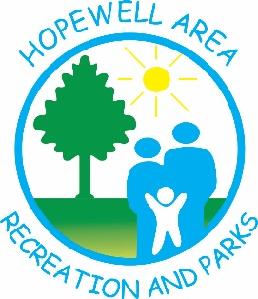
2026 Cash Bingo Dates
January 2nd
March 6th
May 1st
October 2nd
November 6th
December 4th
Doors open at 5:00pm, food and drinks available for purchase. Bingo Games begin at 6:00pm.
Please call 717-993-2255 or email us at info@harp-online.org with any questions
Address: 16 College Avenue Stewartstown, PA 17363

